- GETTING STARTED - Homepage & Exploration

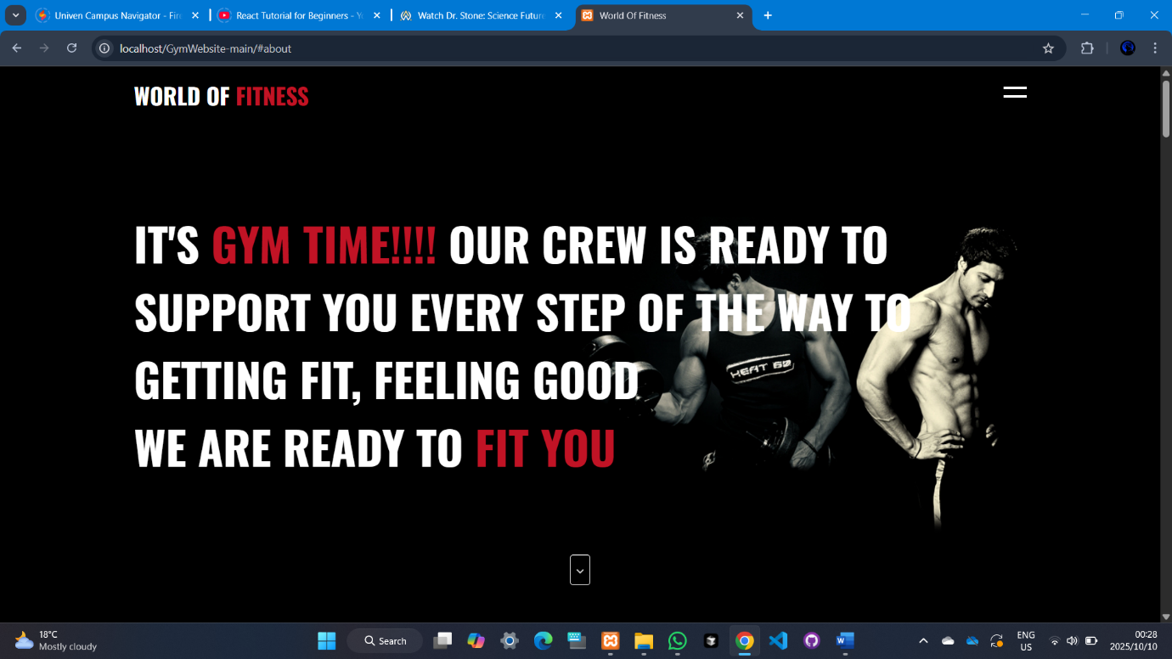

1.1 Landing on the Website
What you see:
- "WORLD OF FITNESS" banner
- Motivational message
- Three main sections: Free Consultation, Best Training, Build Perfect Body
What to do:
- Read through the services to understand what's offered
- Scroll down to see all content
- Use navigation menu (Home, Services, Classes, Contact, Login/Register)
- Click "Services" to learn more about offerings

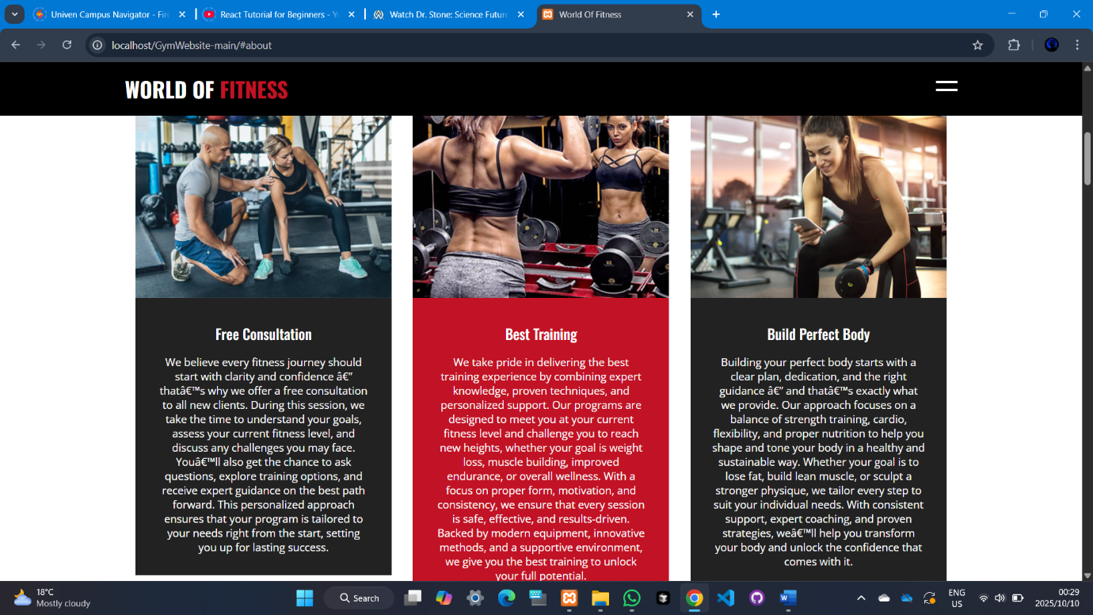

1.2 Exploring Services
What you see:
- Detailed service descriptions
- Three service categories:
  - Cardiovascular Equipment
  - Strength Training Equipment
  - Group Fitness Class
- "Start Now" buttons
What to do:
- Read about each service type
- Identify which services interest you
- Click "Start Now" when ready to register
- Note contact info for questions

- ACCOUNT CREATION - Registration Process

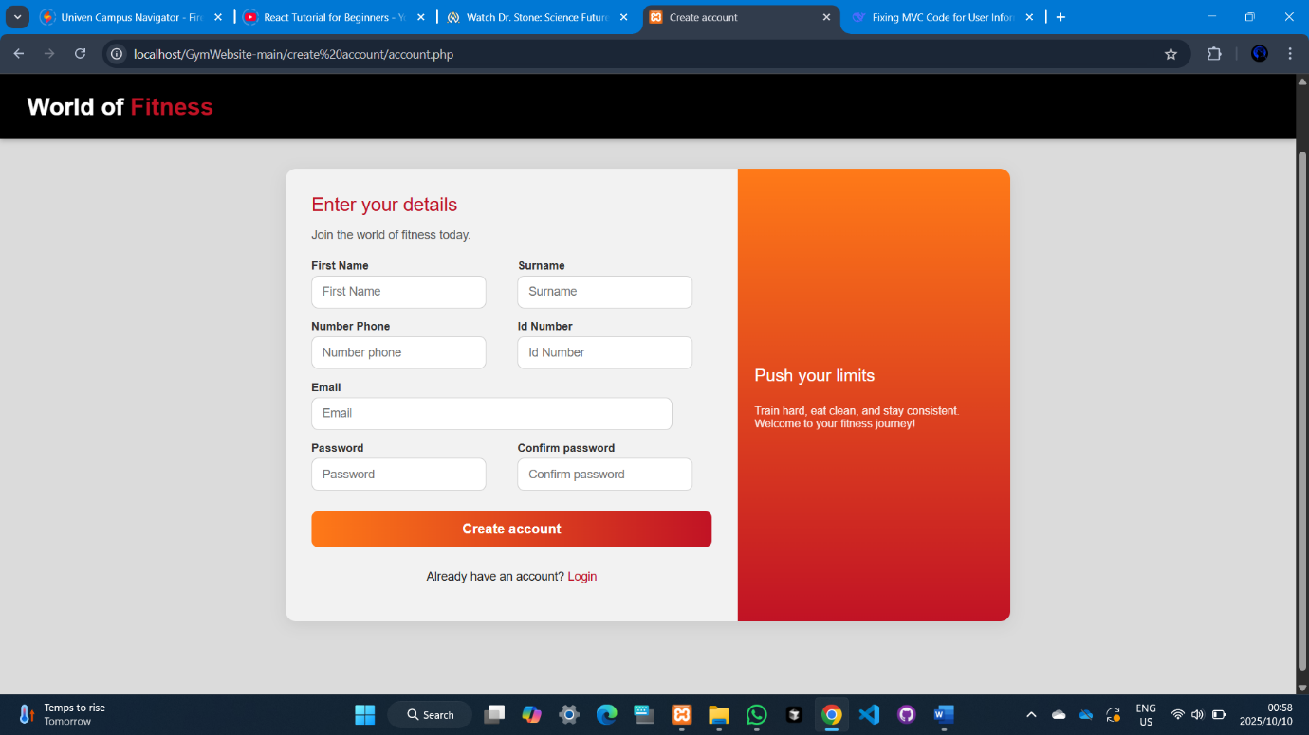

2.1 Access Registration Page
What you see:
- "World of Fitness" header
- "Enter your details - Join the world of fitness today"
- Registration form with required fields
What to do:
- Click "Register" from any page
- Fill in ALL required fields
2.2 Complete Registration Form
Required Fields:
- First Name
- Surname
- Number Phone
- Id Number
- Email
- Password
- Confirm password
2.3 Finalize Registration
What to do:
- Double-check all information for accuracy
- Click "Create account" button
- Wait for confirmation - you'll be redirected to login
- If you have an account, click "Login" instead

- LOGGING IN - Account Access

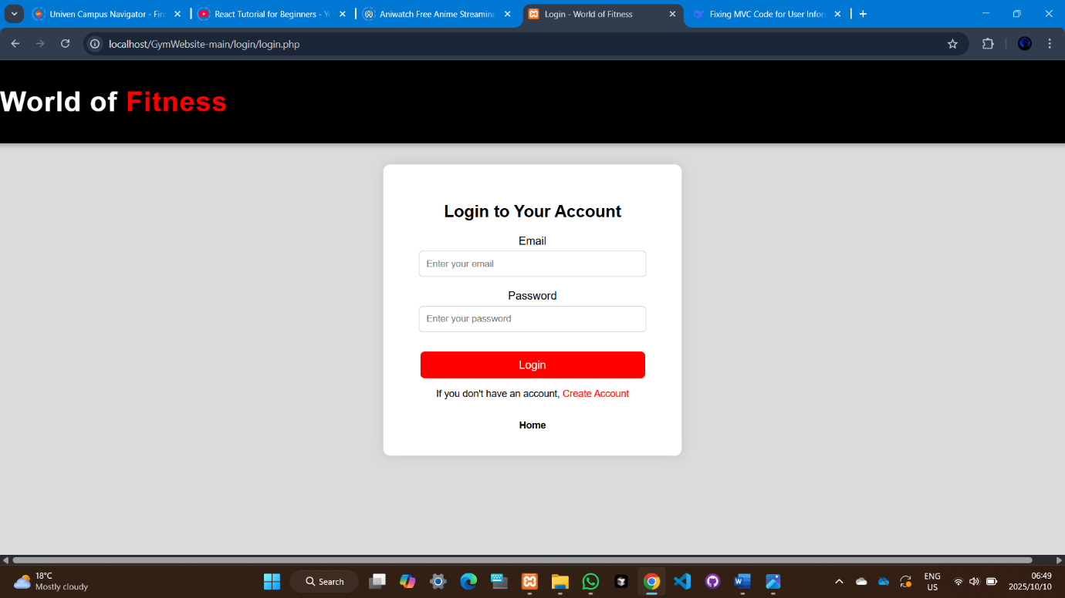

3.1 Access Login Page
What to do:
- Click "Login" from any page
- Enter your credentials:
  - Email
  - Password
- Click "Login" to access your dashboard

- USER DASHBOARD - Your Fitness Hub

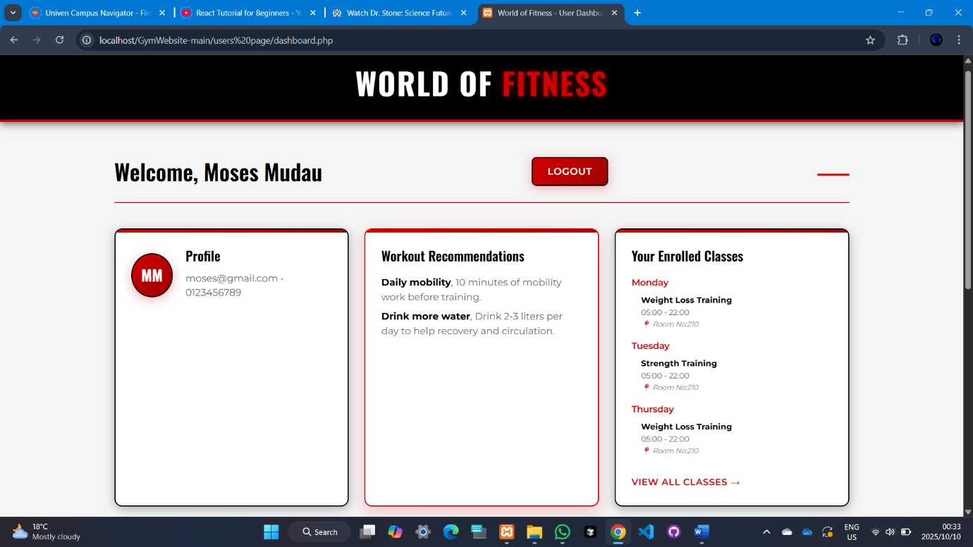
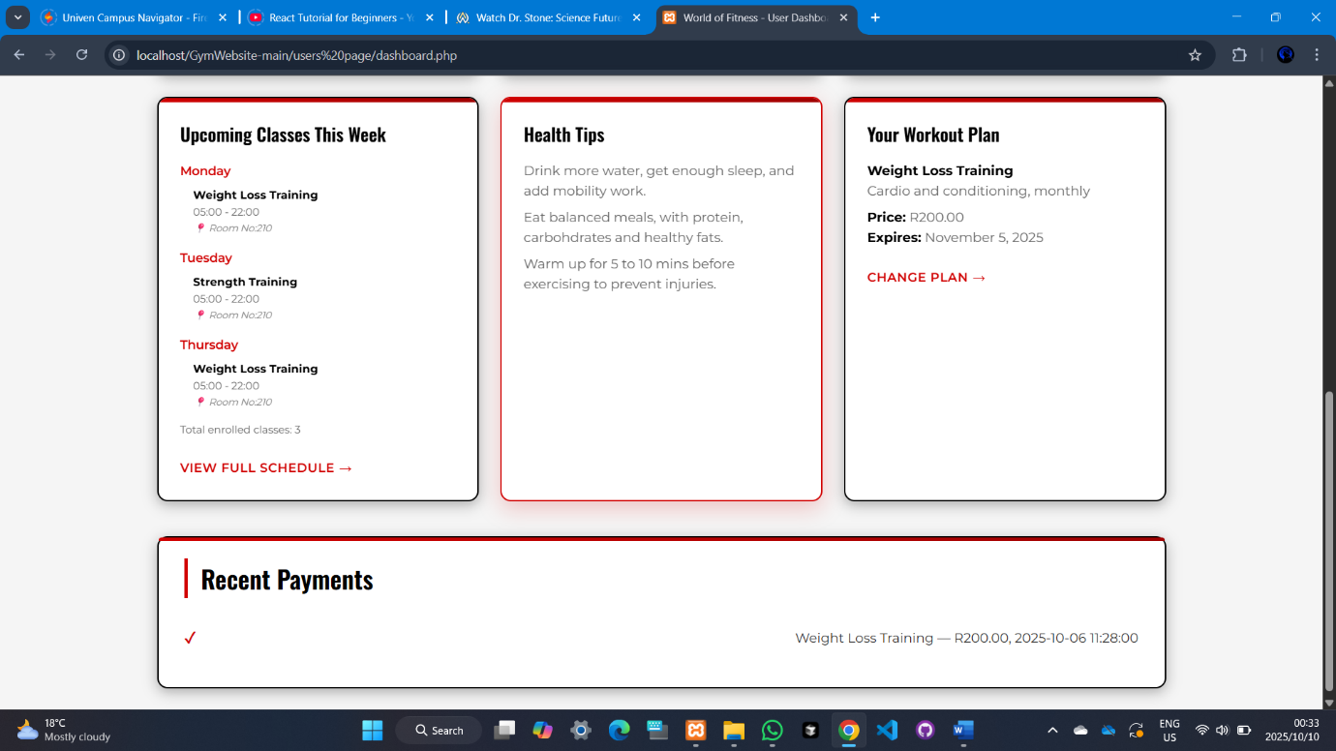
4.1 Dashboard Overview (After Login)
What you see:
- Welcome message with your name
- LOGOUT button
- Profile information
- Workout recommendations
- Your enrolled classes list
- "VIEW ALL CLASSES" link
What to do:
- Verify your profile info is correct
- Read workout recommendations for daily tips
- Check enrolled classes to see your schedule
- Click "VIEW ALL CLASSES" to manage enrollment

- CHOOSING YOUR PLAN - Membership Selection

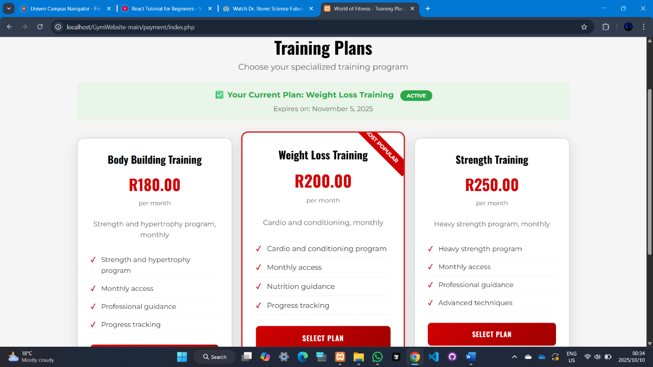

5.1 Access Training Plans
What you see:
- Your current plan (if any)
- Three available plans:
  - Body Building Training - R180/month
  - Weight Loss Training - R200/month
  - Strength Training - R250/month
- "SELECT PLAN" buttons for each
What to do:
- Compare plan features and prices
- Click "SELECT PLAN" on your chosen option
- Complete payment process
- Your membership activates immediately

- BROWSE & ENROLL IN CLASSES

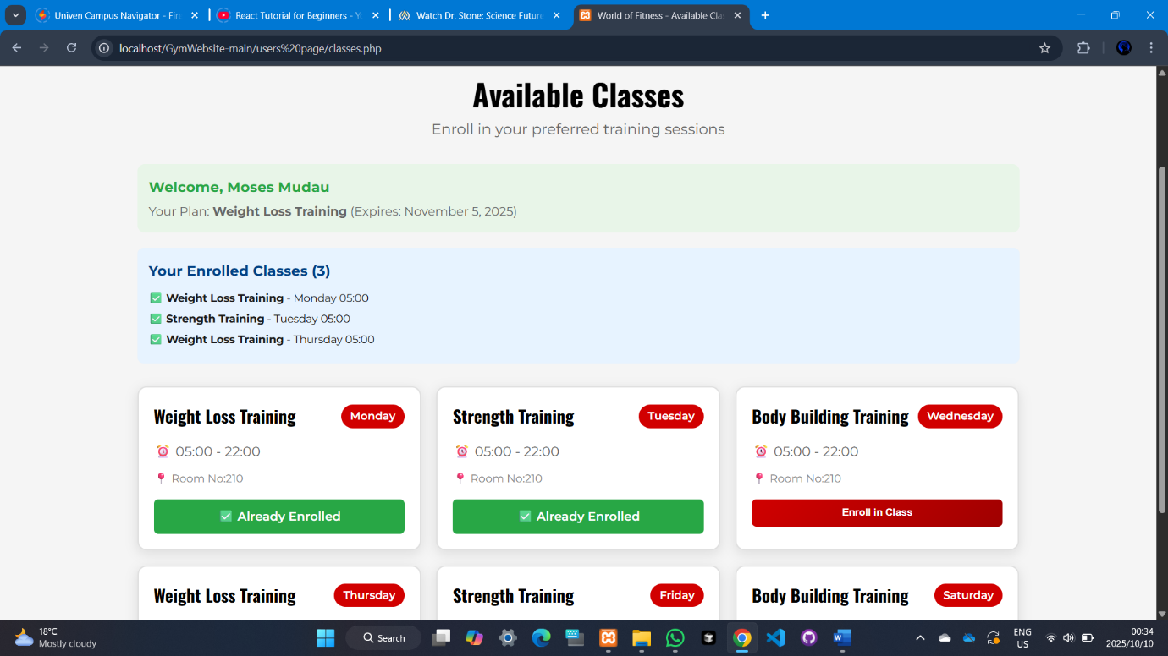
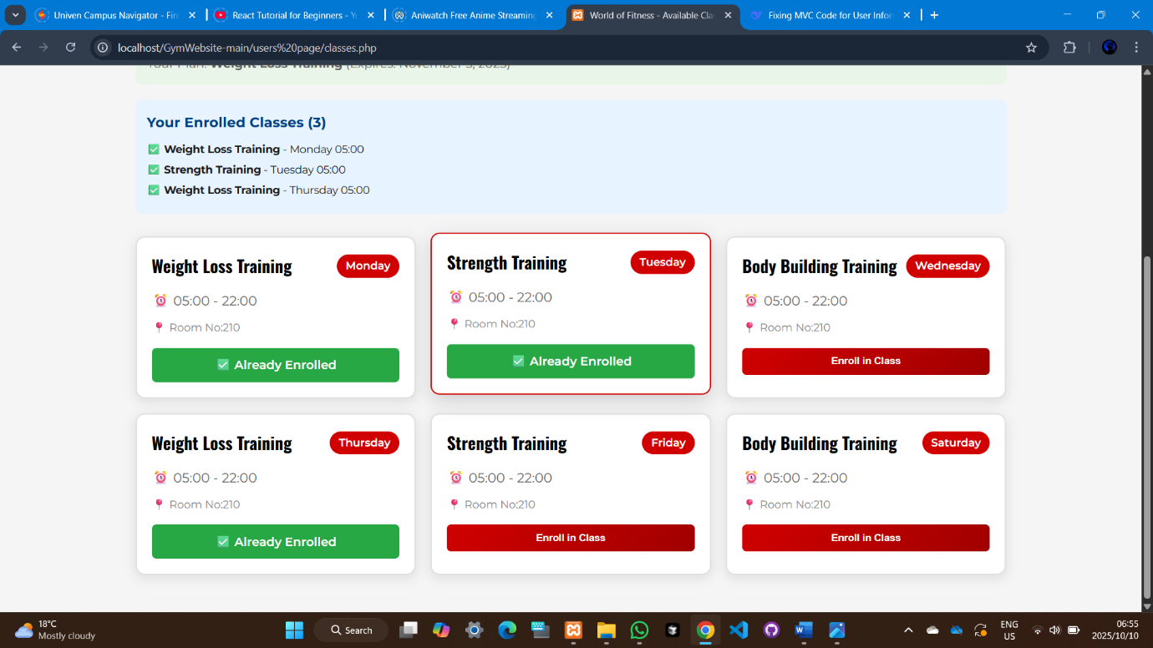
6.1 View Available Classes
What you see:
- Class cards with prices
- "Get Details" buttons
What to do:
- Browse all available classes
- Click "Get Details" on interesting classes
- Note class schedules and rooms
- Enroll in classes that fit your schedule
6.2 Class Enrollment Process
What to do:
- Ensure you have active membership
- Select classes from available options
- Confirm enrollment
- Classes appear in your schedule immediately

7. MANAGING YOUR SCHEDULE

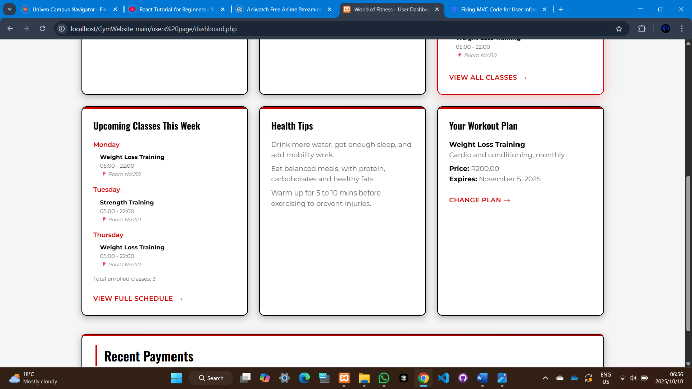

7.1 Weekly Schedule View
What you see:
- Upcoming classes for current week
- Class details: Day, Time, Room
- Total enrolled classes count
- Health tips section
- Your current workout plan
- Recent payments
- "VIEW FULL SCHEDULE" link
What to do:
- Review your weekly schedule
- Note class times and rooms
- Read and follow health tips
- Click "VIEW FULL SCHEDULE" for complete calendar
7.2 Schedule Management
What to do:
- Check schedule daily before gym visits
- Arrive on time for enrolled classes
- Use "CHANGE PLAN" if you want different classes
- Track payments in Recent Payments section

8. GETTING HELP & SUPPORT

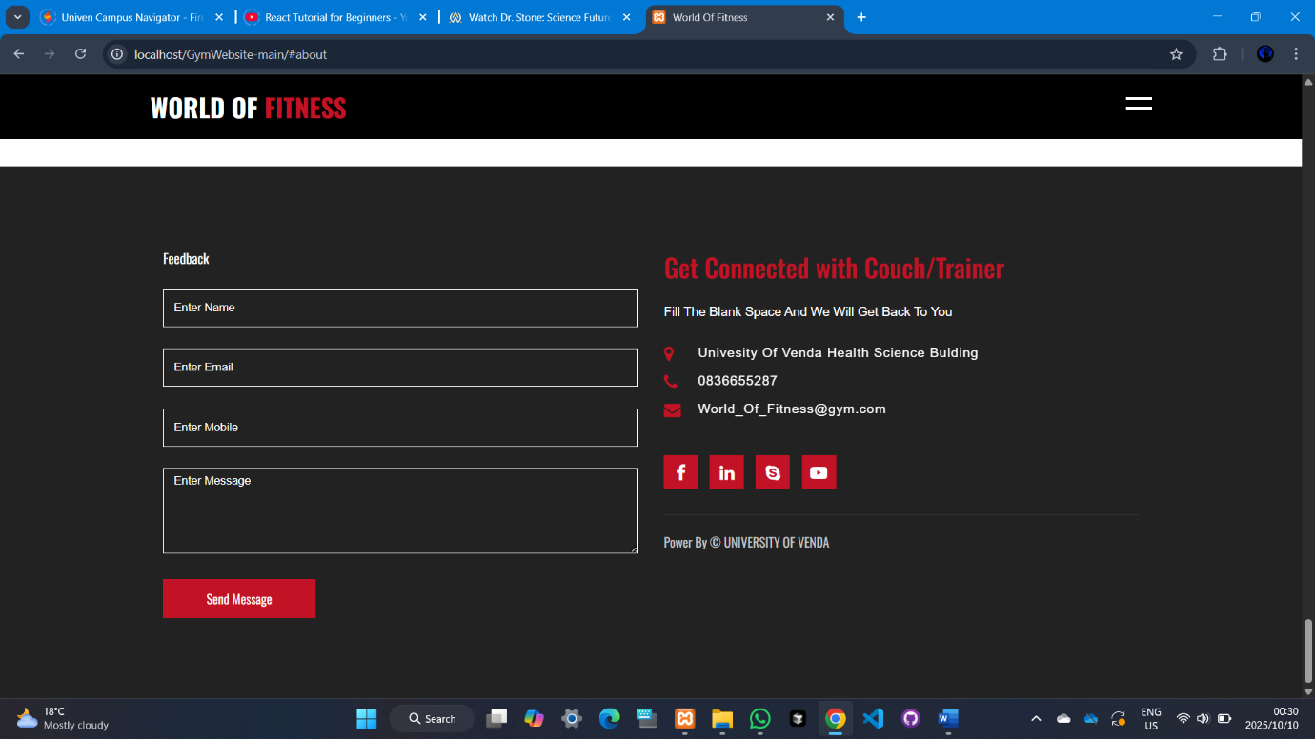

8.1 Contact Page
What you see:
- Contact form with fields:
  - Enter Name
  - Enter Email
  - Enter Mode
  - Enter Message
- Gym contact information
- "Send Message" button
What to do:
- Fill contact form for non-urgent issues
- Call 0836655287 for immediate help
- Email World_OL.Fitness@gym.com for detailed questions
- Visit in person at University Of Venda Health Science Building

